ENEL-UC Berkeley Preliminary Project Report

**Background**

This project uses several different technologies to capture strain due to the backscattering of light. This includes Optical Frequency Domain Reflectometry (OFDR) and Phase-based Time Domain Reflectometry (Φ-OTDR) which is commonly used in Distributed Acoustic Sensing (DAS). Both of these technologies use Rayleigh scattered light, caused by local refractive index fluctuations along the glass core. This information can then be converted into dynamic strain measurements. The two technologies have different capabilities, such as maximum sampling rate and spatial resolution. In particular, a sampling rate of 2.5 Hz and a spatial resolution of 2.6 mm for the OFDR system were used. A sampling rate of 4 kHz and a spatial resolution of 2-7 meters for the Φ-OTDR were used. It is important to note that the OFDR technology is limited to 100 meters of sensing, while the Φ-OTDR technology has the capability to measure up to 10 km. This spatial resolution and sensing distance-sampling rate tradeoff suggests that there are tradeoffs when selecting a technology to determine dynamic strain. This study examines the efficacy of the two technologies for detecting relevant strain phenomena that are indicative of connection degradation.

**Instrumentation**

Analyzers:

1. Optasense ODH 3 Distributed Acoustic Sensor interrogator (Φ-OTDR)
2. Luna Innovations ODiSI6000 Commercial system (OFDR)
3. Alica (BOTDR) (Currently being repaired)

The tower was instrumented with NanZee Sensing NZS-DSS-C02 single mode, tightly buffered fiber optic cables.

Due to the Luna system’s limited sensing length of 100 meters, the system can only be effectively used to measure the local strain at the two flanges. The ODH 3 system was used to measure both the longitudinal and circumferential strain. To capture both global and local strain phenomena, cables were adhered to the wind turbine in both longitudinal (up the height of the turbine tower), and circumferentially (adjacent to the flanges of the tower), as shown in Figure 2.

Table : Comparison of Distributed Fiber Optic Sensing Analyzers

|  |  |  |
| --- | --- | --- |
|  | **Luna** | **ODH 3/ODH 4** |
| Sensing Distance | 100 meters | 10,000 meters |
| Sampling Rate | 2.5 Hz | 200,000 Hz |
| Spatial Resolution | 2.6 mm | ~8 meters (ODH 3) ~2 meters (ODH 4) |
| Strain Resolution | 5 microstrain (Dependent on power loss) | 10 picostrain |

The two analyzers’ capabilities are summarized in Table 1.

**Installation**

Shed Location

Figure : Site Overview of Turbine B6 and Shed Location.

The initial installation was conducted from 10/17/22 – 10/21/22, and the final installation was completed from 12/19/22 – 12/23/22. One turbine (B6 shown in Figure 1) in the Rocky Ridge wind farm was instrumented with fiber optic cables. A ropes team aided in installing and epoxying the cable by rappelling down from the respective platforms for the longitudinal cables, as shown in Figure 2.

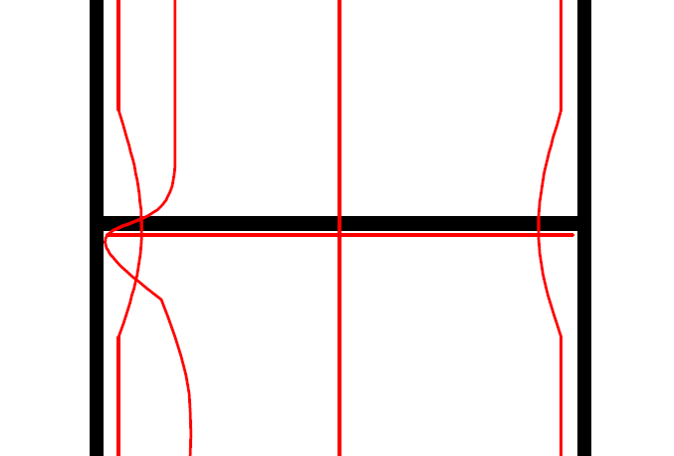

Figure : Cables attached to turbine, with close up of the circumferential cable at the flange

**Long-Term Monitoring Plan**

Take strain data every day for a window of time. Typically, the wind is strongest during the afternoon, so data collected will be taken roughly from 11:00 am – 11:15 am every day for all technologies. If there is a large storm forecasted, strain data will also be taken during the event to capture any large strain inducing events.

**Short-Term Monitoring Plan**

4 Bolt configurations

1. Bolts as is
2. One Loose bolt (60 degrees loosening), directly under one of the longitudinal cables
3. One Loose bolt (Fully loose) directly under one of the longitudinal cables
4. After bolts have been retightened
5. For each bolt configuration
   1. Turbine turned off (Alicia)
   2. Hammer Test (ODH3 and Luna)
      1. One at the first flange (Just above the flange)
         1. Right above one of the channels
         2. In between two of the channels
   3. Brake test (ODH3 and Luna)
      1. Brake test at the top to attempt to excite the first mode (turbine nacelle swaying back and forth)
   4. Nearby Vibration Generation (ODH3 and Luna)
      1. Driving away from the tower, down the road and back
      2. Drive around the turbine
   5. Normal operation (Attempt to record at the same time as other tests). Do this twice, at different times of the day.
      1. During normal operation (~11 am and ~2 pm, Dependent on Wind) (Alicia)
      2. Record for 15 minutes (~11 am and ~2 pm, Dependent on Wind) (ODH3 and Luna)
   6. If applicable, retighten bolts and measure strain (Alicia)

Figure : Hammer test locations, location indicated in actual photo (left), as well as cartoon (right) of the first flange above the base.

Hammer Here

Cables

Loosen Bolt

Loosen Bolt

**

Figure : Circumferential data from the Luna system at different times.

As shown in Figure 4, we see that half of the turbine tower is in compression, and the other half is in tension, indicating bending. The data plotted was zeroed from the beginning of the measurement, which indicates an increase in strain, possibly due to an increase in wind. Interestingly, the bending of the turbine tower seems to indicate a change in direction of the steady wind, as seen in the plots. This data will be corroborated with the SCADA data that we receive from ENEL’s internal database later, to confirm our analysis. During our short-term tests, we saw that during the hammer tests, Luna experienced significant signal loss, most likely due to the high strain-rate induced by the impact.

Circumferential Loop 1

Circumferential Loop 2

Longitudinal Channel 4 (Flipped)

Longitudinal Channel 3

Longitudinal Channel 2 (Flipped)

Longitudinal Channel 1

Figure : Blue line indicates the braking event, with the different channels indicated on the left-hand side.

Figure : Examples of ODH 3 strain data and its associated frequency spectra for the bottom most channel

As shown in Figure 5 and Figure 6, the decimated data can then be plotted and analyzed quickly to determine changes in modal properties. However, due to Luna’s spatial resolution, the local changes in the strain field may be able to better show bolt loosening effects over time.

**Data Workflow**

1. ODH 3 and Luna collect data
2. Data is saved to a local external hard drive
3. Data is also uploaded to cloud storage
4. Data decimation
   1. Data is decimated to 100 Hz for ODH 3 due to high sampling rate
   2. Data is not decimated for Luna due to low sampling rate
5. Apply filters to data to remove low frequencies if applicable.

**Next Steps**

* Bolts have arrived, we can conduct the short-term test before and after again, with different datatypes.
* Repair external disk for DAS.
* Next visit planned: Mid-August